Name: Modi Tejasv M.

Subject :Python (task-1)

1. Write a python program to print the numbers from 1 to 100.

Ans:

foriinrange(1,51):

    print(i)

output:

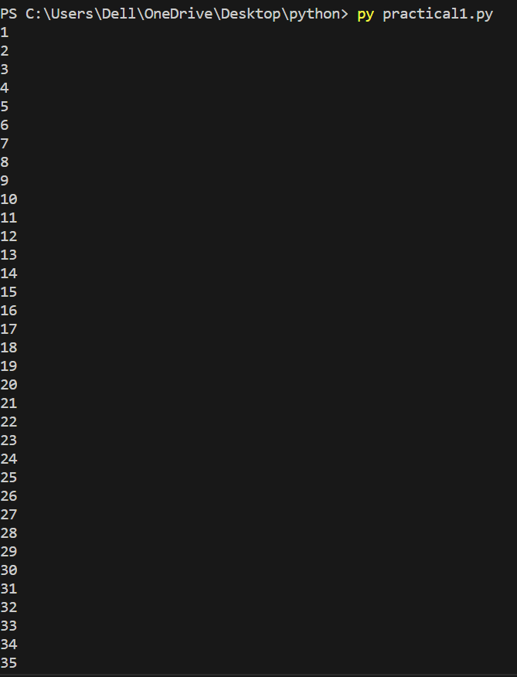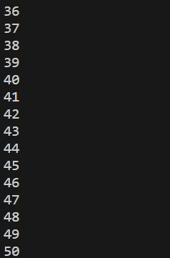

1. Write a python program to print all the number between 11 to 100 which are multiple of 7.

Ans:

foriinrange(14,100,7):

    print(i)

output: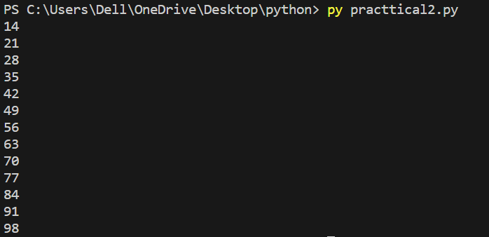

1. Weite a pyrhon program to print numbers from 75 to 21 in reverse number

Ans:

foriinrange(75,20,-1):

     print(i)

output :

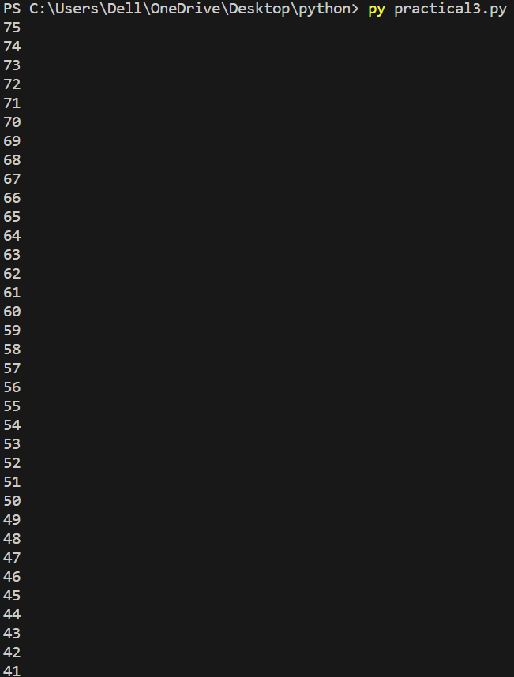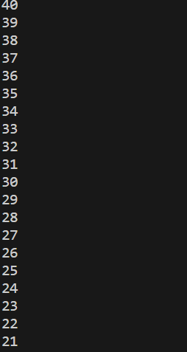

1. Write a program to take 3 number from user and find the largest number from it and print the result.

Ans:

var1=int(input("enter the number1"))

var2=int(input("enter the number2"))

var3=int(input("enter the number3"))

if(var1>var2):

    if(var1>var3):

        print("the largest number is ",var1)

elif(var3<var2):

    print("the largest number is ",var2)

else:

    print("the largest number is ",var3)

output:

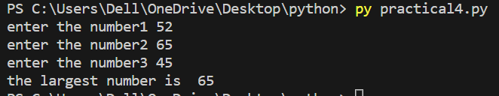

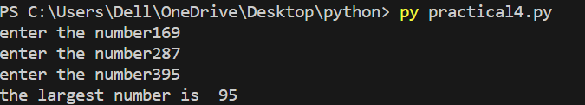

1. Write a program to take percentage of student as an input and display the grade of student

If percentage have per >=85 grade A

Per < 85 and per >=75 grade B

Per < 75 and per >=65 grade c

Per < 65 and per >=55 grade D

Per < 55 and per >=40 grade E

Per < 40 grade F

var1=int(input("enter the percentage"))

if(var1>=85):

    print("your grade is A")

elif(var1<85andvar1>=75):

    print("your grade is B")

elif(var1<75andvar1>=65):

    print("your grade is C")

elif(var1<65andvar1>=55):

    print("your grade is D")

elif(var1<55andvar1>=40):

    print("the grade is E")

else:

    print("the grade is F")

output:

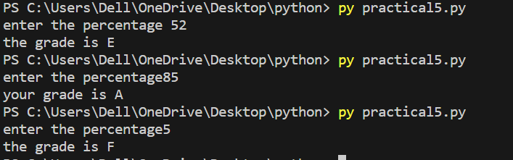

1. Write a python program to take input from the user and find whether the number is odd and even.

Ans.

var1=int(input("enter the number1"))

if(var1%2==0):

    print("the number is even")

else:

    print("the number is odd")

output:

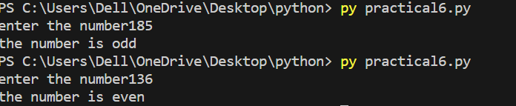

1. Write a python program to take 7 numbers from user and calculate the sum of those 7 numbers in result

Ans:

sum=0

foriinrange(1,8):

    var=int(input("enter the number"))

    sum=sum+var

print("the sum of 7 number is ",sum)

output:

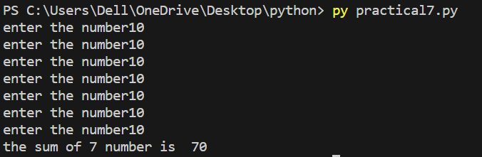

1. Write a python program to calculate sum of all numbers between 71 to 80 .

Ans:

var=0

foriinrange(71,81):

   var=var+i

print("the sum between 71 to 80 is ",var)

output:



1. Write a python program find the product of all the numbers between 21 to 30

Ans:

product=1

foriinrange(21,31):

    product=product\*i

print("the product is",product)

output:



1. Write a python program to find given number is prime or not .

Ans:

var=int(input("enter the numer"))

foriinrange(2,var):

    if(var%i==0):

        print("number is not prime")

        break

    else:

        print("number is prime ")

        break

output:

